**Review comments**

**Reviewer 1:**

With great interest I've read this really interesting paper on macrolide resistance genes. The authors have written a very good paper. The research has some important limitation, but the authors have all discussed them in the "discussion" session. Therefore, I have only a few less important remarks:

1. Do the authors have data or literature to support the statement in the Methods that a 6 month “wash-out” is enough to go back to a “baseline” situation?

**[Our response]**

In the methods and supplementary data (See main manuscript: page ? and line ?; Online supplement: page ? and line ?), we include the text that a macrolide non-recipient was defined as someone who had not received any macrolide therapy in the 6 months prior to enrolment in the study. We chose to set 6 months as a cut-off due to reports from previous literature. For example, Malhotra *et al.*, showed that macrolide resistance genes returned to baseline levels at 6 months (PMID: 17292768). This is further supported by a meta-analysis by Costelloe *et al.* (PMID: 20483949).

1. The authors have a 4-week wash-out for other antibiotics but how about e.g. clindamycin (Lincosamides) in this erm setting?

We have confirmed that all participants including patients and close contacts did not receive any antibiotic during the 4-week wash-out period. This includes clindamycin.

1. In the cohort overview results, the authors mention a 12-month interval used for macrolide as an exclusion but in the methods it’s 6 months. Could the authors explain this discrepancy?

**[Our response]**

We apologise for this error. To clarify, all patients in the macrolide non-recipient group had not received any antibiotic in the 6 months prior to sample collection. We have now revised the manuscript and amended any discrepancies (See main manuscript: page ? and line ?; Online supplement: page ? and line ?).

1. Could the authors give more detail on the relationship between patients and controls? Are they siblings or spouses or others? This might influence contact. I imagine that transmission risk is different between a friend you see frequently or your sibling or your partner… Do the authors have details and could this have influenced the data (e.g. more similarity between partner vs friends?)

**[Task]**

1. For missing data, contact clinicians: Done
2. Description of relationship details: Done

**[Our draft]**

We provide a breakdown of the relationship between patients and close contacts in Table R1, below. We categorise the relationships according to both level of contact and type of relationship as both may influence likelihood of transmission. As these tables illustrate, 92% (86/93) of close contacts are cohabitant to patients. Of these, XX% are family members and XX% are partners. We agree that this detail is an important consideration and have included this table in online supplement (e-Table ?).

We also agree that both the type of relationship and level of contact may influence the degree of transmission. Our study set out to address whether there was any evidence of transmission of macrolide resistance genes between patients and close contacts and whether macrolide use was associated with transmission risk. While the different degree of contact is an important consideration for the propensity of AMR transmission, such subgroup analysis is beyond the scope of this study. To emphasize the importance of different degree of contact on propensity of AMR transmission, a small discussion has been included in the revised manuscript (See main manuscript: page ? and line ?)

* The majority of the close contacts are cohabitants <- major determinant of transmission

**Table R1.** Summary of all participants’ relationship details in this study

|  |  |  |  |
| --- | --- | --- | --- |
| **Relationship** | **Sample size** | **Details** | **Percentage**  **(%)** |
| Family members  (Parent, siblings and children) | 31 | Cohabitant  (>6 months) | 90  (28/31) |
| Regular contact  (>2 times per week in the last 2 years) | 10  (3/31) |
| Partner, spouse and de facto | 59 | Cohabitant  (>6 months) | 98  (58/59) |
| Regular contact  (>2 times per week in the last 2 years) | 2  (1/59) |
| Friend | 3 | Cohabitant  (>6 months) | 0  (0/3) |
| Regular contact  (>2 times per week in the last 2 years) | 100  (3/3) |

**Reviewer 2:**

Wang and colleagues seek to assess whether long-term macrolide therapy poses a risk for onward transmission of resistance genes in patients with chronic respiratory disease and their co-inhabitants. Though limited in scope (focusing on a select number of macrolides + tetracycline genes by qPCR), I can’t fault the technical execution of the molecular methods presented. I have some concerns about the experimental design, analysis, and conclusions.

1. That the relative abundance of ermB is higher in MR and MNR group. However, they also tested 9 additional resistance genes (multiple hypothesis testing) and I don’t see where this has been adjusted for. With adjustment, significance will probably be lost.

**[Pre and post FDR results]: Done**

**[Our response]:**

We agree with the reviewer that adjusting for multiple testing is an important consideration - this is also how we would normally approach this type of analysis. Our initial analysis was performed without false discovery rate correction as we were concerned about inflating the risk of Type II error. Below we provide the outcome tables without and with FDR adjustment (Benjamini and Hochberg method) using the “stats” package in R (PMID: 30124010). As Table R4 shows, difference in *erm*(B) levels between MR and MNR group is not significant after FDR adjustment. In response to the reviewer’s comment, we have amended the manuscript to reflect this outcome (See main manuscript: page ? and line ?).

* We opted to assess a wide range of AMR genes to comprehensively assess the effect of macrolide treatment on gene carriage and transmission.

Explanation of Type I and Type II error

Type I and Type II errors form an inverse of relationship; when one goes down, the other goes up and vice-versa. Depending on the correlation structure of the tests, the correction methods are quite conservative which may lead to a relative high rate of false negative rates. Therefore, we did not perform FDR adjustment in the first place. However, we agree that controlling Type I errors is extremely important especially when researchers perform multiple testing. Given that 10 tests were performed, the probability of at least 1 false positive result is 0.41 (*P*[making at least 1 error in m tests]=1-(1-α)m). In our revised manuscript, we have included post-FDR *P* value in all tables (See main manuscript: page ? and line ?).

Our conclusion is in support of previous findings

The novelty of this study was the comparison between patients and close contacts

**Table R3.** Resistance gene detection frequency in patients stratified by macrolide use.

|  |  |  |  |  |
| --- | --- | --- | --- | --- |
| **Resistance gene** | **MR** | **MNR** | ***P* values** | ***P* values**  **(post-FDR)** |
| *erm*(A) | 3.8%  (2/53) | 5.0%  (2/40) | 0.99 | 0.99 |
| *erm*(B) | 89%  (47/53) | 95%  (38/40) | 0.46 | 0.66 |
| *erm*(C) | 19%  (10/53) | 13%  (5/40) | 0.57 | 0.71 |
| *erm*(F) | 68%  (36/53) | 78%  (31/40) | 0.36 | 0.62 |
| *mef* | 74%  (39/53) | 83%  (33/40) | 0.33 | 0.62 |
| *msr*(A) | 36%  (19/53) | 25%  (10/40) | 0.37 | 0.62 |
| *msr*(E) | 66%  (35/53) | 73%  (29/40) | 0.65 | 0.72 |
| *tetM* | 94%  (50/53) | 100%  (40/40) | 0.26 | 0.62 |
| *tetO* | 64%  (34/53) | 78%  (31/40) | 0.18 | 0.62 |
| *tetW* | 85%  (45/53) | 98%  (39/40) | 0.07 | 0.62 |

**Table R4.** Normalised resistance gene abundance in patients stratified by macrolide use.

|  |  |  |  |  |
| --- | --- | --- | --- | --- |
| **Resistance gene** | **MR** | **MNR** | ***P* values** | ***P* values**  **(post-FDR)** |
| *erm*(A) | 0  (0.0-10.5) | 0  (0.0-7.1) | 0.39 | 0.99 |
| *erm*(B) | 7.5  (0.0-12.4) | 6.9  (0.0-10.8) | 0.045* | 0.66 |
| *erm*(C) | 0  (0.0-13.2) | 0  (0.0-8.0) | 0.14 | 0.71 |
| *erm*(F) | 7.6  (0.0-12.4) | 6.2  (0.0-11.9) | 0.22 | 0.62 |
| *mef* | 4.4  (0.0-6.7) | 3.9  (0.0-7.5) | 0.20 | 0.62 |
| *msr*(A) | 0  (0.0-13.2) | 0  (0.0-9.1) | 0.15 | 0.62 |
| *msr*(E) | 7.3  (0.0-13.0) | 5.7  (0.0-15.9) | 0.07 | 0.72 |
| *tetM* | 5.9  (0.0-8.9) | 5.5  (2.1-7.6) | 0.42 | 0.62 |
| *tetO* | 6.4  (0.0-10.5) | 6.3  (0.0-12.3) | 0.39 | 0.62 |
| *tetW* | 5.2  (2.7) | 4.8  (2.2) | 0.46 | 0.62 |

* indicates the significance of this comparison lost after FDR correction

**Table R5.** Paired assessment of the resistance gene detection frequency between patients and close contacts stratified by macrolide use.

|  |  |  |  |  |  |  |
| --- | --- | --- | --- | --- | --- | --- |
| **Resistance gene** | **MR vs MRCC** | | | **MNR vs MNRCC** | | |
| **Odds ratio**  **(95% CI)** | ***P* value** | ***P* values**  **(post-FDR)** | **Odds ratio**  **(95% CI)** | ***P* value** | ***P* values**  **(post-FDR)** |
| *erm*(B) | 3.4  (0.5-22.9) | 0.21 | 0.38 | 1.3×10-7  (0-Inf) | >0.99 | 0.99 |
| *erm*(C) | 5.1  (0.6-41.9) | 0.13 | 0.29 | 8.5  (0.4-163.9) | 0.16 | 0.99 |
| *erm*(F) | 11.8  (2.3-59.6) | 0.0029† | 0.020 | 1.7  (0.4-7.6) | 0.50 | 0.99 |
| *mef* | 7.3  (1.9-28.4) | 0.0044† | 0.020 | 1.3  (0.3-6.9) | 0.75 | 0.99 |
| *msr*(A) | 1.5  (0.5-4.9) | 0.48 | 0.62 | 1.8  (0.4-8.2) | 0.43 | 0.99 |
| *msr*(E) | 0.8  (0.3-2.7) | 0.74 | 0.83 | 1.1  (0.3-4.5) | 0.87 | 0.99 |
| *tetM* | 2.1×10-7  (0-Inf) | >0.99 | 0.99 | N/A | N/A | N/A |
| *tetO* | 2.7  (0.8-8.5) | 0.099 | 0.29 | 1.7  (0.4-7.6) | 0.50 | 0.99 |
| *tetW* | 2.4  (0.5-12.0) | 0.29 | 0.44 | 2.5×10-7  (0-Inf) | >0.99 | 0.99 |

† indicates the significance of this comparison remained after FDR correction

**Table R6.** Assessment of long-term macrolide use on onward transmission risk of macrolide resistance genes.

|  |  |  |  |
| --- | --- | --- | --- |
| **Resistance**  **gene** | **Macrolide recipient group vs Macrolide non-recipient group** | | |
| **Odds ratio**  **(95% CI)** | ***P* value** | ***P* values**  **(post-FDR)** |
| *erm*(A) | 1.0  (0-Inf) | >0.99 | 0.99 |
| *erm*(B) | 1.0  (0.4-2.9) | 0.96 | 0.99 |
| *erm*(C) | 1.0  (0.07-13.9) | >0.99 | 0.99 |
| *erm*(F) | 1.0  (0.4-2.5) | 0.97 | 0.99 |
| *mef* | 1.6  (0.6-3.9) | 0.33 | 0.99 |
| *msr*(A) | 1.3  (0.3-5.0) | 0.73 | 0.99 |
| *msr*(E) | 0.6  (0.2-1.5) | 0.25 | 0.99 |
| *tetM* | 0.5  (0.09-2.7) | 0.43 | 0.99 |
| *tetO* | 0.9  (0.4-2.2) | 0.82 | 0.99 |
| *tetW* | 0.7  (0.3-2.0) | 0.55 | 0.99 |

(1)“Onward transmission” of resistance genes, i.e. (that is) increased relative risk of resistance gene co-detection in co-habitants of patients on long-term macrolide therapy. However, onward transmission is somewhat speculative since it is not really possible to establish “transmission” of a resistance gene by the methodology employed. A patient could have acquired the resistance gene from their co-inhabitant initially for example. We are really looking at the effect of “household antibiotic use” on risk of resistance detection in untreated individuals. The word transmission is misleading.

(3) One would need to isolate a resistant organism from both patient and co-inhabitant and test this by strain typing or WGS analysis (as a start).

**[Our response]:**

1. The authors are very aware that determining evidence of transmission is incredibly difficult to demonstrate in a cross-sectional cohort study.
2. We have published in this space [Anushia’s paper]
   1. Short description of Anushia’s paper
3. However, AMR genes are clinically important
4. We use detection of AMR genes as a marker for transmission
5. There are no studies of this sort
   1. Mughini-Gras 2019- PMID 31439317: Humans to human transmission are the main source of community acquired antibiotic-resistant bacteria
   2. Examples of antibiotic resistance (bacteria) transmission (MRSA):
      1. PMID11101914: household contacts (27/87, 31%) vs the community (14/77, 18.1%)
      2. PMID19923490: two-thirds (67%; n = 56) of household contacts -> MRSA positive
6. Therefore these findings provide useful early evidence
7. We have included a detailed discussion of the need for large, longitudinal studies to assess the transmission of AMR and the contribution of antibiotics to this transmission risk.
   1. Need to measure not just AMR gene but carriage and transmission of specific isolates

(1)“Carriage and transmission of resistance genes” For macrolides, this is an incredibly difficult question to address by the applied methodology given the apparently high prevalence of macrolide resistance in the environment/microbiome.

(2)Macrolide and Tetracycline resistance genes are frequently the most highly detected resistance genes reported in resistome studies. Thus, even healthy individuals may harbour these genes anyway, perhaps through maintenance via other, as yet unrecognised, selective pressures.

**[Our response]**

1. Agree that macrolide and tet resistance genes are highly prevalent in both the environment and within the human microbiome
2. We have contributed to the literature to show this [papers]
   1. Why might this be the case? E.g. high amount of tetracycline in the environment endogenously
3. As the reviewer notes, even in the close contacts of macrolide non-recipients, carriage of macrolide and tetracycline resistance genes were high [stats]
4. Such prevalence does indeed confound the ability to demonstrate that macrolide use is a primary contributor to carriage
5. This is why it was necessary to have a high sample size
6. **Global macrolide/tetracycline resistance:** 31.0% (pneumococcal macrolide resistance, PMID: 15963272), 8.7% and 24.3% (Tetracycline for MRSA and S, pneumoniae, PMID: 26989065)
   1. Most of these resistance studies above collected samples from patients, not healthy individuals
7. **Macrolide use drives macrolide resistance:** Macrolide use is the most important driver of macrolide resistance (PMID: 17292768-Malhotra, PMID: 29669883, PMID: 23532241, PMID: 17195698, PMID: 16469851)
8. **Household transmission is important:** Humans to human transmission are the main source of community acquired antibiotic-resistant bacteria (PMID 31439317) and transmission risk of MRSA is higher among household contacts than among community members (PMID 11101914)
9. **In this study, we not only assessed the carriage but also assessed the abundance**

**In Australian population, the macrolide carriage rate is lower than many other countries:** In Australia, 32.4% carried ermB, this rate is not high as compared with other countries (e.g, Morocco 90.2%, Belgium 90.2%, France 90.0%, Poland 80.8%) (PMID: 27709102)

(3)There seem to be many unanswered questions that the study fails to address. Just looking at a few resistance genes at a single anatomical site is somewhat limited in scope considering the complex effects of antibiotics on the microbiome/resistome.

1. The positioning of this study focused on macrolide exposure on macrolide resistance
2. We chose 10 genes that reflect the most commonly carried genes associated with macrolide use.
3. ermA/B/C/F, msrA/E and mef are six common macrolide resistance genes that are carried on mobile genetic elements (ref)
   1. Clinically important
      1. ermA is found in XX
      2. ermB – Haemophilus, strep..
   2. We provide a detailed overview of the clinical relevance of these genes in the discussion (lines XX).
4. Why tet included:
   1. tetM and tetO were found on the same mobile genetic elements with macrolide resistance gene (Tn5358, Tn1545 for tetM, Tn2009 for tetO, PMID: 12936983, PMID: 15837373-tetO, PMID: 7648031-tetM)
   2. tetW was recently found to be strongly associated with macrolide therapy (Steven’s paper, PMID: 30875247)

**[Find 2-3 papers that describe the global frequency of macrolide and tet resistance genes]**

**Reference**

**Prevalence of macrolide resistance gene in global (**PMID:27709102)

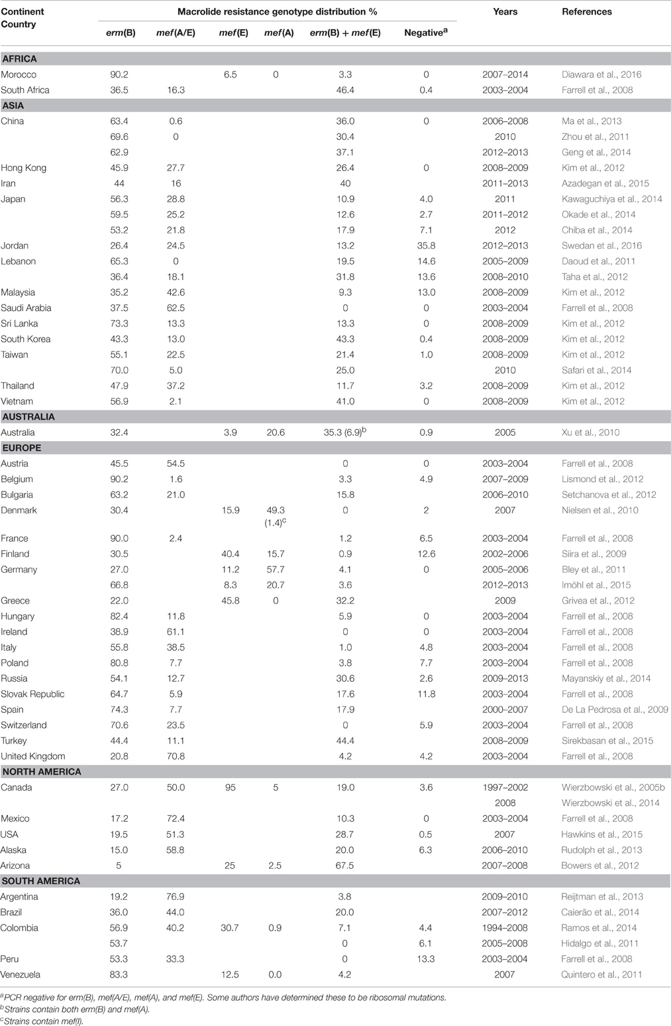

That “long-term term antibiotic macrolide therapy was not associated with increased risk of acquiring macrolide resistance genes”.

A major shortcoming is that only macrolide/tetracycline resistance was assessed.

* We agree.
* We note this in the discussion.
* We have previous studies that have provided a metagenomic assessment of the AMR gene carriage.
* We used the findings from these papers to determine the selection of the 10 genes assessed here.

Macrolide exposure can co-select for other resistance genes which may be an even greater concern (thinking of MDR plasmids etc.).

**[Our response]**

**[Preparation]**

1. Tet genes are found on plasmids
2. Describe how you identified these genes

We provide an overview of the selection of resistance genes in response to the reviewer’s previous question. We would also highlight that these genes represent genes commonly associated with plasmids. For example plasmid 1 – ermB tetM. This plasmid is found in … Plasmid 2 – ermF tetW. This plasmid is found in …

We

Given that, macrolide resistance acquisition might restrict the use of not only all macrolides, but also tetracyclines.

Further, the lung microbiome is relatively stable under antibiotic treatment and the gut is less so. The impact of macrolides on the gut may be much more relevant in terms of potential transmission of resistance.

I understand that the focus is on the airway but what happens in the gut seldom stays in the gut, where resistance is concerned.

**[Our response]**

1. We agree that resistance in the gut is also important. The gut represents an important route of transmission.
2. E.g. Carbapenemase-producing enterobacteriaceae (CPE) <- ask lito about AMR infections transmitted via gut
3. Important reservoir of resistance.
4. We have published in this space
   1. Our recent paper already compared the fecal resistomes between adult CF and healthy individual (PMID: 33250435). We found that aminoglycoside resistance was a primary contributor to the divergence in resistome composition between CF and healthy stool, reflecting the high tobramycin use in CF indivudals
   2. Our current study, however, focused on the airway resistance transmission; however, we agree that resistance in the gut is also important
5. The focus of this manuscript is the oropharyngeal AMR carriage.
6. Important for upper and lower respiratory infections
   1. E.g. Man et al
7. In response to this comment, we expand on our discussion of the importance of the human microbiome (including the gut) as a potential transmission of resistance in the revised manuscript (See main manuscript: page ? and line ?)

In summary, the authors assess the impact of antibiotic therapy on macrolide/tetracycline resistance gene carriage/transmission in the airway and fail to detect a convincing signal that might suggest this is a real clinical problem.

However, the study completely overlooks both other (non-macrolide/tetracycline) resistance mechanisms as well as the selective pressures placed on the intestinal microbiome and the risk of transmission of resistant gut pathogens. The authors have not sufficiently assessed this element and I’m concerned that it conveys a false message e.g. “macrolide selection is probably a non-issue”.

Antibiotic selection in the gut (initially on commensal species) likely preceded the global dissemination of cephalosporinase resistance genes (i.e. CTX-M-15), for example. The effect of antibiotic selection in the airway and corresponding impact on AMR dissemination has yet to be concussively investigated. Thus, not looking at the gut, in the context of an AMR study is an oversight if onward transmission is the focus. Further the narrow range of analysis (10 genes) in the lung is a concern. Many other relevant resistance events could have been missed.

**[Preparation]**

# Point to the strength of the study (Cover letter could help)

As we mentioned in our manuscript:

1. This study is the first cross-sectional cohort study that report the impact of long-term macrolide therapy on oropharyngeal macrolide resistance gene carriage in healthy close contacts of people with chronic lung diseases
2. It mainly focused on evaluating the impact of long-term macrolide therapy on airway macrolide resistance genes development and potential onward transmission risk of these genes to the close contacts
3. To assess the impact of long-macrolide therapy on airway macrolide resistance genes development, a total of 93 people with chronic respiratory conditions (53 receiving long-term macrolides, 40 macrolide naïve) were included, and we analysed the carriage and abundance of 7 common macrolide resistance gene and 3 macrolide-related genes
4. To explore the potential risk for onward transmission, 93 paired samples from close contacts of subjects were collected and were subjected to three analyses: 1) by comparing resistance between close contacts of macrolide recipients and non-recipients 2) by comparing detection rates within groups 2) by comparing transmission risk between macrolide recipient and non-recipient groups
5. We found that long-term macrolide exposure is associated with increased macrolide resistance carriage within patients (before FDR), however, importantly, no increase in resistance carriage was observed in close contacts of patients. These findings support the continued safe use of macrolide maintenance therapy in chronic respiratory disease.
6. Limitation of this study is also well-described in the discussion section
7. Taken together, we think this study is

**[Our responses]**

**Reviewer 3:**

The authors address the issue of whether long term macrolide therapy increases macrolide resistance and whether macrolide resistance increases in close contacts. There are a number of papers showing increased macrolide resistance and resistance genes with macrolide use, so the novelty lies in the issue of whether this spread.

1. I am not sure that clinical readers will understand the difference between gene detection and gene abundance, and perhaps some mention of qualitative vs quantitative or presence/absence vs total amount is appropriate for readers not familiar with microbiome work.

**[Preparation]**

* We recognise this issue
* It is a complex issue where both contribute to our understanding
* Within the author team, we have discussed this at length
* We define these as … which we feel provides the clearest definition for the reader.
* In response, we have [included definitions of each term] in attempt to further clarify.

1. For a clinical journal I think you need to put your data into a clinical context - what does all this mean in terms of clinically significant resistance in bacteria that would normally be treated by an oral macrolide (the real concern about community macrolide resistance). especially S.pneumoniae and other common streptococci.

**[Preparation]**

* For discussion with Rachel and Lucy’s

1. There is no comment about whether the close contacts had administration of macrolides within a reasonable period (say 12 months) of sampling. With not vast numbers, this is a potential confounding variable.

**[Preparation]**

* we included in online supplement

* This is an important feature of the study

* we have now moved this to the main text

**[Our responses]**

We include information about duration of macrolide use and length of time without macrolide use in the Methods section under “study design and setting” (line XX) and in the online supplement material. For clarity, all close contacts have not received any macrolide in the prior 6 months. We chose to set 6 months as a cut-off due to reports from previous literature. For example, Malhotra *et al.*, showed that macrolide resistance genes returned to baseline levels at 6 months (PMID: 17292768). This is further supported by a meta-analysis by Costelloe *et al.* (PMID: 20483949).

In revising the manuscript, we have clarified the definitions of both a macrolide recipient and a macrolide non-recipient (lines XX) and presented below.

1. With respect to the key issue of "does this resistance transfer to others, the key issue is whether the sample size is adequate to reach the conclusion of "no it doesn't". It is not defined what you would have considered sufficient gene transfer of resistance to be clinically or even epidemiologically relevant.

The reviewer raises a very important point that we have discussed at length. The clinical implications from this study are difficult to define. Macrolide resistance is a clinical concern in [settings]. In these cases, ermB is the primary resistance mechanism.

**[Preparation]**

* Incidence where there was evidence of transmission (e.g. 2/53 times).:

* HOW MANY TIMES DID “TRANMISSION” OCCUR

1. Definition of co-carriage and transmission
   1. Co-carriage/dependency: incidence of 1-1 and 0-0 vs incidence of 0-1 and 1-0
   2. Transmission: incidence of 1-1 vs incidence of 0-1 and 1-0
2. How many times did transmission occur?

**[Tables]**

**Table R7.** Incidence of transmission

|  |  |  |
| --- | --- | --- |
| **Resistance gene** | **Macrolide group**  **(Percentage, %)** | **Non-macrolide group**  **(Percentage, %)** |
| *erm*(A) | 0  (0/53) | 0  (0/40) |
| *erm*(B) | 77  (41/53) | 80  (32/40) |
| *erm*(C) | 4  (2/53) | 3  (1/40) |
| *erm*(F) | 42  (22/53) | 53  (21/40) |
| *mef* | 55  (29/53) | 53  (21/40) |
| *msr*(A) | 15  (8/53) | 10  (4/40) |
| *msr*(E) | 23  (12/53) | 35  (14/40) |
| *tet*(M) | 91  (48/53) | 95  (38/40) |
| *tet*(O) | 45  (24/53) | 53  (21/40) |
| *tet*(W) | 68  (36/53) | 78  (31/40) |

**[Our responses]**

Given you did show erm and mef detection was more common in contacts of macrolide users, I am not clear at all how you can justify your conclusion that resistance is not trasnmissable into the community - in fact the opposite finding would appear to be supported by your data - as you acknowledge in your discussion.

The last sentence of the abstract is therefore far too strong and not supported by your data.

**[Preparation]**

**A figure to explain this ?**

The last sentence of the abstract states: “”. This is in reference to the “model 2” where the effect of macrolide use is tested. Here, there was no indication that macrolide use was associated with co-carriage of resistance genes. However, as the reviewer highlights, we do see evidence of co-detection of ermF and mef in the macrolide recipients. Independently, this was not found in the macrolide non-recipients. We feel that the higher co-detection of ermF and mef in the macrolide recipients is not evidence to suggest macrolide use is associated with co-detection. [further explanation]

1. Two models were employed to assess co-carriage (dependency) and transmission risk
   1. Revise discussion part as we confuse others about the first model?
2. The first model is within group comparison, the second model is between group comparison
   1. Our first analysis model focus on the co-carriage of resistance genes in each treatment group (incidence of 1-1 and 0-0 vs incidence of 0-1 and 1-0)
   2. Our second analysis model focus on the impact of macrolide therapy on transmission risk (Presence/absence of treatment (1/0) effect on transmission (1-1) and no transmission (0-1 and 1-0))
3. The significance of ermF and mef that found in the first model is not an indication of macrolide effects on transmission risk, this is because
   1. The first model aims to evaluate whether the resistance gene in close contacts is dependent/independent of that in patients in each treatment group, thus, 0-0 pairs were also included and considered as dependent pairs; however, 0-0 pairs can not be counted as transmission evidence
   2. Two treatment groups were subjected to the first model separately. Statistically speaking, P values cannot be compared directly
4. Our conclusion is:
   1. However, macrolide use was not associated with increased macrolide resistance gene detection rate and there was no evidence that long-term macrolide use increases the onward transmission risk to their close contacts
   2. It is appropriate because
5. In the discussion I think you have to note that the community data you have is an Australian context. Australia has seen much less use of oral macrolides, and especially problematic ones like Azithromycin, than has, for example, the US and hence international surveillance data typically shows much less clinical macrolide resistance in your population.

**[Preparation]**

# Get statistics: Done

**[Our response]**

* We agree that the community data you have is an Australian context, we had revised our manuscript and made it clear the conclusion drawn in this study was based on Australian population
* [We provide the statistics for macrolide use between Australia, Europe and the USA.]
* Australia does use a lot of macrolide
* A discussion of macrolide usage especially Azithromycin is included in the discussion section

**[Data]**

DDD: Defined daily dose

1. **Australia:**

Unit: DDD per 1,000 occupied bed days

***Source 1:*** *Australian Commission on Safety and Quality in Health Care. AURA 2021: fourth Australian report on antimicrobial use and resistance in human health. Sydney: ACSQHC; 2021.*

* 1. Macrolides: **~2.3** DDD/1 000 inhabitants/per day in 2017 drop to **~1.8** in 2019
  2. Azithromycin:
     1. the rate of inappropriate prescription of all azithromycin prescription is huge 26.5% (n=891)
     2. There was a huge rise in the proportion of private prescriptions for azithromycin throughout the 10-year period. To support this view, average monthly private prescriptions of azithromycin were 423 in 2010 (0.07 per 100 GP visits), increasing to 1,424 in 2019 (0.16 per 100 GP visits).
     3. there was a slight increase in the overall rate of PBS prescribing of antimicrobials that have restricted benefits with azithromycin increasing from 0.84 to 1.1 per 100 prescriptions
     4. Top 10 most commonly prescribed antimicrobials in NAUSP (National Antimicrobial Utilisation Surveillance Program) contributor hospital

1. **Europe:**

Unit: DDD per 1 000 inhabitants per day

***Source:*** *European Centre for Disease Prevention and Control. Antimicrobial consumption in the EU/EEA (ESAC-Net) - Annual Epidemiological Report 2020. Stockholm: ECDC; 2021.*

J01F: Macrolides, lincosamides and streptogramins

* 1. Community usage:
     1. 2020: **2.39** DDD/1 000 inhabitants/ per day (compound annual growth rate -4%)
  2. Hospital usage:
     1. During 2011-2020: No significant EU/EEA trends were detected for consumption of macrolides, lincosamides and streptogramins (ATC group J01F).
     2. 2020: **0.17** DDD/1 000 inhabitants/ per day (compound annual growth rate 3.9%)

1. **USA: Although the WHO promotes the use of DDDs as metrics of drug use, but America do not**

Source: CDC antibiotic resistance & Patient Safety Portal

1. In 2020, 88 prescriptions of macrolides were dispensed in U.S. outpatient pharmacies for every 1,000 persons.
2. In 2020, 29 million prescriptions of macrolides were dispensed in U.S.outpatient pharmacies.

Source: https://clincalc.com/DrugStats/Drugs/Azithromycin

1. 2019: 3.62 prescriptions/1 000 patients/per day (calculated by myself)
2. **Other countries/region have higher macrolide usage (>15%)**

Unit: DDD per 1 000 inhabitants per day and proportion of total consumption

***Source:*** *WHO report on surveillance of antibiotic consumption: 2016-2018 early implementation. Geneva: World Health Organization; 2018. Licence: CC BY-NC-SA 3.0 IGO.*

1. Region of the Americas: Canada 3.29 (19.3%)
2. Region of Eastern Mediterranean Region: Jordan 4.66 (52.2%)
3. Region of Western Pacific Region: Japan 4.59 (32.3%), Republic of Korea 4.69 (17.0%)

Australia

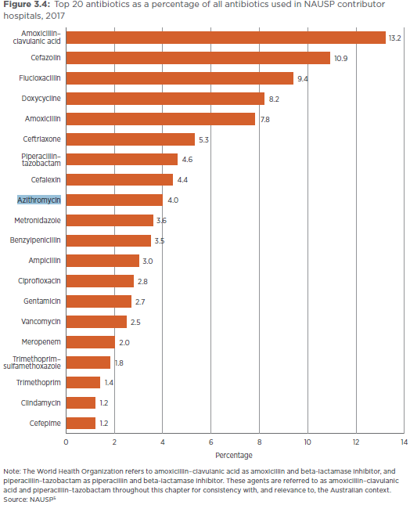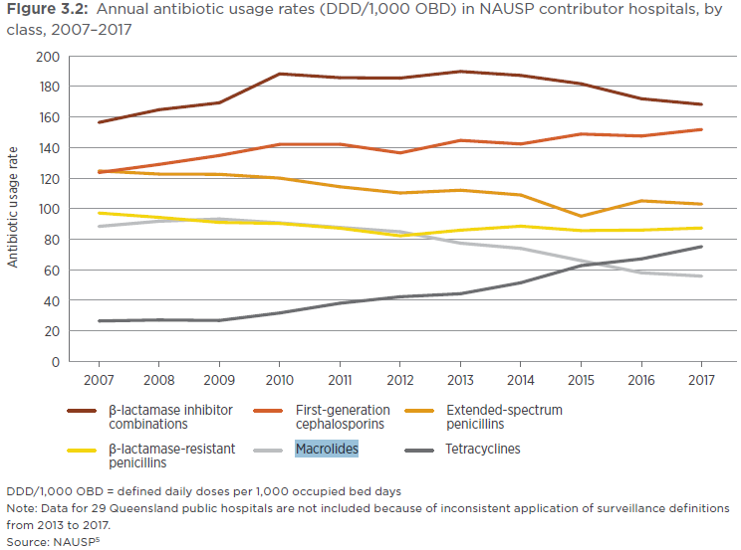

Europe

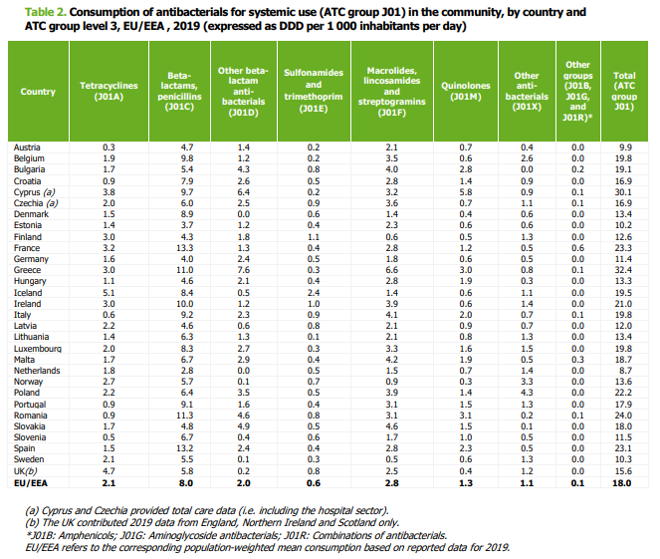

USA

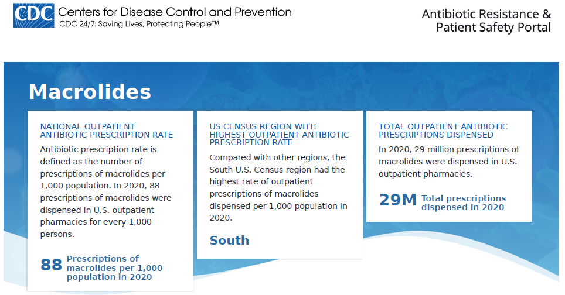

(1)Very few of the close contact groups had any significant chronic lung disease. Do you think this may exert a protective effect on macrolide resistance transfer because they will not have as disordered a microbiome?

(2)We know that CF and bronchiectasis patients can and do transfer multi-resistant organisms to each other, but not to healthy contacts. This should at least be reflected on in the discussion.

We agree

We originally had discussion of both the clinical stability of the patient population as well as the fact that the close contacts did not have a chronic lung disease.

Patients and close contacts were stable at the time of sample collection and close contacts did not have a chronic lung disease. The risk of transmission of resistant bacterial populations would therefore be less than between two people with chronic lung diseases during periods of exacerbation. For example, periods of exacerbation can include increased coughing,37, 38 which has been shown to promote dissemination of potentially resistant bacteria through the production of cough aerosols.39, 40 Further, during periods of stability, intact commensal microbial systems, including those in the oropharynx, resist colonisation by external bacterial populations.41 This protection is greatly reduced when microbiota are disrupted, such as during respiratory viral infection.42 The risks of onward transmission of resistant bacterial populations might therefore vary according to the health of both azithromycin recipients and close contacts.

**[Preparation]**

**Statistical Review Comments:**

The primary objective of this prospective study is to estimate and compare macrolide resistance gene detection rates and abundances between MR, MNR, MRCC, and MNRCC cohorts. Study design, data collection, primary endpoints, and statistical methods were clearly described. Logistic regression models were used to associate cohorts with detection and transmission status. Results were presented adequately and clearly. Conclusions were drawn appropriately. I have one minor suggestion (not a concern or question):

1. Seems authors could try logistic GEE model to estimate and compare 4 cohorts (MR, MNR, MRCC, and MNRCC) in one model with respect of resistant genes detection. This would be more efficient than first comparing within treatment pairs then between treatment groups.

**[Preparation]**

1. Background:
   1. The GEE logit estimates the same model as the standard logistic regression (appropriate when you have a dichotomous dependent variable and a set of explanatory variables). Unlike in logistic regression, GEE logit allows for dependence within clusters, such as in longitudinal data, although its use is not limited to just panel data
   2. it’s a marginal model. GEE computations are usually easier than mixed-effect model computations. GEE does not use the likelihood methods that mixed-effect models employ, which means GEE can sometimes estimate more complex models.

Bin

1. **Mughini-Gras 2019:** Humans to human transmission are the main source of community-acquired β-lactam-resistant E.coli
   1. Most community-acquired β-lactam-resistant E.coli carriage was attributed to human-to-human transmission within or between households in the open community (60·1%, 95% credible interval 40·0–73·5)
2. **Knox 2015_Trends in microbiology:** Several studies have highlighted the role of the household as the primary reservoir for S. aureus in the community 24, 25, 41, 43, 44, 45, 46, 47, 48, 49, 50, 51, 52, 53, 54, 55, 56, 57, 58. The events that follow a CA-MRSA infection in a household include an increase in: (i) the risk of infections among other household members 26, 44, 45, 48, 49, 50, 51; (ii) MRSA colonization among other household members 46, 47, 52, 53, 54, 55, 56, 57, 59; and (iii) contamination of environmental surfaces 24, 25, 58. These reports have described epidemic clones that ‘ping pong’ among family members 26, 51, resulting in high rates of recurrent infection. Eradicating S. aureus carriage from household members and the environment in an effort to reduce the frequency of these infections has achieved mixed results 60, 61.
3. Staphylococcus aureus nasopharyngeal carriage rates and antimicrobial susceptibility patterns among health care workers and their household contacts
4. Transmission of methicillin-resistant Staphylococcus aureus within a household
5. Prevalence of nasal colonization among patients with community-associated methicillin-resistant Staphylococcus aureus infection and their household contacts
6. Staphylococcus aureus nasal colonization among pediatric cystic fibrosis patients and their household contacts
7. Molecular epidemiology and household transmission of community-associated methicillin-resistant Staphylococcus aureus in Hong Kong